**COSC 3304 – Algorithms Design and Analysis**

**Assignment 7**

**Due: 11:59pm, 03/19/2024**

1. What are the pre-order and post-order of the binary search tree below (30 points):

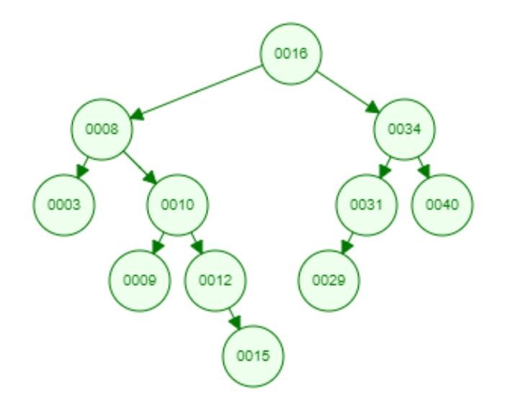

Pre-order:

|  |  |  |  |  |  |  |  |  |  |  |
| --- | --- | --- | --- | --- | --- | --- | --- | --- | --- | --- |
| 16 | 8 | 3 | 10 | 9 | 12 | 15 | 34 | 31 | 29 | 40 |

Post-order:

|  |  |  |  |  |  |  |  |  |  |  |
| --- | --- | --- | --- | --- | --- | --- | --- | --- | --- | --- |
| 3 | 9 | 15 | 12 | 10 | 8 | 29 | 31 | 40 | 34 | 16 |

1. Please insert keys 22, 58, 30, 42, 37, 40, 38, 19, 26 into an initially empty BST (show the new tree after each insertion. 30 points).
2. A green circle with black numbers

   Description automatically generated
3. A diagram of a number

   Description automatically generated with medium confidence
4. A diagram of a number

   Description automatically generated with medium confidence
5. A diagram of a number

   Description automatically generated
6. A diagram of a flowchart

   Description automatically generated
7. A diagram of a diagram

   Description automatically generated
8. A diagram of a diagram

   Description automatically generated with medium confidence
9. A diagram of a diagram

   Description automatically generated with medium confidence
10. A diagram of a tree

    Description automatically generated

1. Please delete keys 31, 24, 16, and 8 from the BST below sequentially, (show the new tree after each deletion. 40 points).

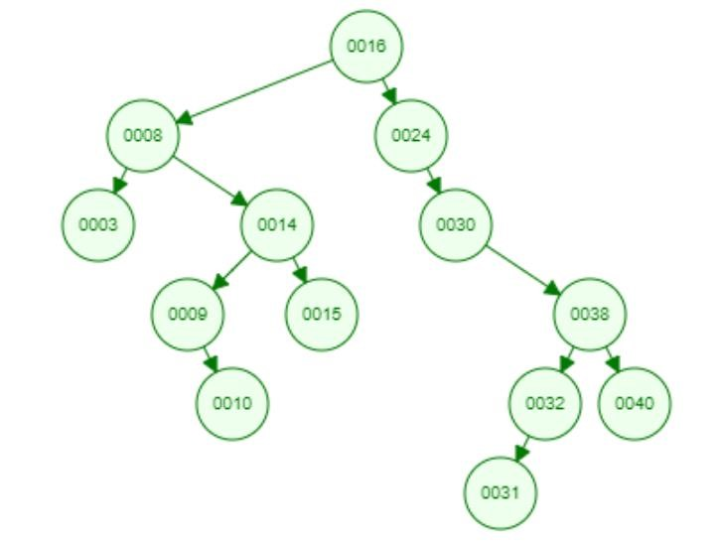

1. Delete 31 A diagram of a diagram

   Description automatically generated
2. Delete 24 A diagram of a diagram

   Description automatically generated
3. Delete 16 A diagram of a diagram

   Description automatically generated
4. Delete 8 A diagram of a diagram

   Description automatically generated